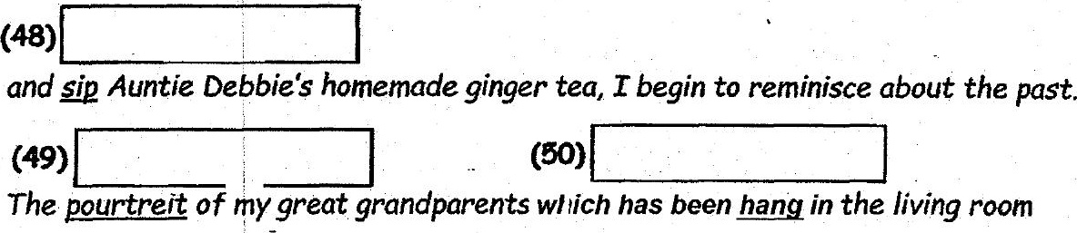

remains where it is. They are perhaps celebrating the reunion as well!

_ Adapted from htto:/evaloque.itife

| Score: